ENTRADAS CALAMARCITOS EN ALL I PEBRE
MOLUSCO, GLUTEN, FRUTOS SECOS
CLOCHINAS AL VAPOR MOLUSCO

JAMON SERRANO Y QUESO
ENSALADA DE AGUACATE Y FRUTOS SECOS LACTEO, HUEVO, SULFITOS, FRUTOS SECOS
>>>>>>>>>>>>>>>>>>>>>>>>>>>>>>>>>>>>>>>>>>>>>>>>>>>>>>>>>>>>>>>>>>>>>>>>>>>>>>>>>>>

SEGUNDO PAELLA VALENCIANA GLUTEN
(a elegir) ESCALOPE DE LA CASA HUEVO, GLUTEN, LACTEO
RABO ESTOFADO SULFITOS, GLUTEN
MERLUZA AL CHEF GLUTEN, SULFITOS, PESCADO, LACTEO
>>>>>>>>>>>>>>>>>>>>>>>>>>>>>>>>>>>>>>>>>>>>>>>>>>>>>>>>>

POSTRES TARTA TIRAMISSU GLUTEN,LACTEOS,FRUTOS SECOS ( A ELEGIR) SANDIA O NARANJA PREPARADA
CALABAZA ASADA GLUTEN,LACTEOS
PUDDING DE CALABAZA LACTEOS,GLUTEN
MANZANA ASADA
BISCUIT GLACE GLUTEN,LACTEOS
<< <<<<<<<<<<<<<<<<<<<<<<<<<<<<<<<<<
AGUA
BEBIDA VINO
(1 POR PERSONA) CERVEZA
REFRESCO
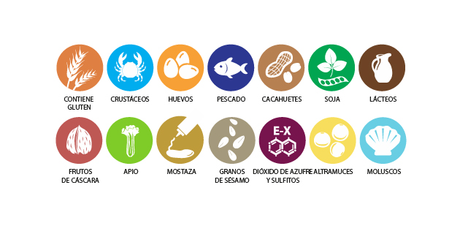WWW.FACEBOOK.COM/BARRESTAURANTEFELIX

